The Saint Matthias Messenger. Published Monthly Volume 20 Issue 12–December 2023

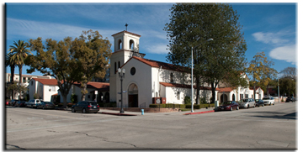

Saint Matthias Episcopal Church
7056 Washington Avenue
Whittier, CA 90602
(562) 698-9741
office@stmatthiaswhittier.org
www.stmatthiaswhittier.org

Office Hours
Monday-Friday
10AM-4 PM

Holy Eucharist
Sundays at 8 AM

Holy Eucharist
Sundays at 10 AM

10 AM Services Streamed at
facebook.com/stmatthiaswhittier
Christmas is my favorite time of year. I feel like there is something special in the air. I love the decorations and the lights. I love the delicious cookies and goodies. I love the parties and gatherings and getting together with family and friends. But Christmas is about more than the lights and decorations and goodies.
Christmas is about love.

First John 4.9-10 says, “God’s love was revealed among us in this way: God sent his only Son into the world so that we might live through him. In this is love, not that we loved God but that he loved us and sent his son to be the atoning sacrifice for our sins.” It is very clear that God loves us, but He also wants us to love Him and to love each other. Matthew 22:37-39 reads, “…’You shall love the Lord your God with all your heart, and with all your soul, and with all your mind.’ This is the greatest and first commandment. And a second is like it: ‘You shall love your neighbor as yourself.’ “ Therefore, it seems that LOVING is the most important thing that we can do in our lifetime.

One of the ways that we show God how much we love Him is by loving each other. It’s easy to love those people who are similar to us or special to us such as our families and friends. But how easy is it to love acquaintances or strangers? How are we at loving those who have a different background than we do or come from a different socioeconomic class than we do? How are we at loving those who look or act differently than us or have a different opinion on something? How easily do we love people that have a different political or religious view or someone we’ve had a disagreement with? Do we easily love those who look differently, talk differently, live differently, or dress differently?
Since we are human and far from perfect, we can and do struggle with loving some people. But God never gives up on loving us, and he doesn’t want us to give up on loving others. We can start with a smile, a kind word, an act of helpfulness or just caring and listening. We can make a point of being accepting, inclusive and welcoming. It’s amazing how much these simple acts can change another person’s entire day. I think this is what Father Bill refers to as “living from the inside out rather than from the outside in.”

It is also important to remember that many people are going through difficult times. The holidays can be depressing or a reminder of a painful memory or of the loss of a loved one. Maybe they are missing someone very special to them. Not everyone wants to be showered with love and holiday joy. Sometimes the best way to love someone is to give them their space and privacy. Being aware of others’ needs and acting accordingly, is another example of doing the loving thing.

While we can’t change the whole world, we can change the world directly around us. We can remember to love one another as God loves us, not just during the Christmas season, but throughout the whole year too.
So, “Go in peace to love and serve the Lord, DOING THE LOVING THING!”

Merry Christmas!
Janice Webster
+ + +
They shall be like a tree planted by water, sending out its roots by the stream. It shall not fear when heat comes, and its leaves shall stay green; in the year of drought it is not anxious, and it does not cease to bear fruit. - Jeremiah 17:8

Fellow Saint Matthians!

First and foremost, I want to wish all of you, your families, your relatives, your friends, and your beloved a spectacular holiday season. May all of you enjoy this time with all your being: please carve out time and enjoy the beautiful scents; enjoy the delicious tastes; enjoy the incomparable beauty of our surroundings; but, above all, allow the spirit to imbue you with The Divine Love.

Advent and Christmastide are one of the most, if not the most beautiful times of the year. Our historic Saint Matthias is bedecked in garlands in anticipation of celebrating the “word becoming flesh”, our Advent Candles are being lit each week in adherence to our noble tradition, our spirits are being imbued and uplifted every week with Kevin’s and the choir’s gorgeous music, the lectionary, the thoughtful reflections on the lectionary by our presiding priests, and, of course, the ultimate symbolism of love and communion, the sharing of bread and wine together.

Our Rooted in Abundance Stewardship Campaign 2023 has been a wonderful experience for me and, I hope, it has been at least an enlightening and inspirational one for all of you.

During the Campaign, we have had the opportunity to candidly share our thoughts with each other on the current state of Saint Matthias, the viability of its future, and the evolving role it should play in the 21st Century. These interactions with you have shaped and re-shaped my perspectives on Saint Matthias and its future.

During the Campaign, we have enjoyed hearing from our fellow parishioners on the role Saint Matthias plays in their lives, the community, and the world. We have been treated to Chapel Talk presentations by Bill Geiger, Eileen Weiss, Glenn and Terry Dodd, J.D. Neal, and Jan Biby. Each of these speakers expressed in their own unique and inspiring ways what Saint Matthias and the Saint Matthias Community mean in their lives and how important it is to support the Saint Matthias mission.

During the Campaign, we have also dreamed together of a reinvigorated community, of an educational and theological center of excellence, of vibrant reading book discussions, of a Soup Hour with homemade soup and homemade bread for those in need as well as for the Whittier community at large, of a tranquil Saint Francis Patio offering a midday respite for uptown workers, and of a church life full of baptisms, confirmations, and weddings.

As you have undoubtedly read in our Midweek publication, we have extended our Rooted in Abundance Stewardship Campaign 2023 until the end of the year. We have done this because we want Saint Matthias to be in a solid financial position to be able to retain and grow our current programs and fund a full-time rector. You know that such funding is considerable and means that our financial pledges must grow from two-thirds of the operating budget to three-fourths.

For those of you who have already submitted your pledge, I want to thank you for your love and generosity for supporting Saint Matthias, its Gifts, Ministries, and Services, and the Divine Love it imbues in all of us.

For those of you who have not yet carved out time to complete and submit your pledge cards, please do not procrastinate any longer. Please take time and complete and mail your pledge cards to us today. Pledge your time, pledge your talent, AND / OR pledge your money in whatever capacity you are comfortable doing. You and God alone know what you can contribute. Every pledge brings us closer to sustaining the viability of our Saint Matthias community.

In sincere gratitude,

Christopher Lavagnino
Stewardship Campaign 2023 Chairperson

+ + +
From our Presiding Bishop Michael Curry

You may know me as the pastor who is always talking about love, and I am. But today I am mindful that the urgency of love—true, sacrificial love that respects all of humanity—is not just a good feeling, and it is not easy.
We are called to a love that demands much from us. We are called to a love that tells the truth.
Today I raise my voice for love because more than 10,000 people have died in Gaza, including more than 4,000 children.
The violence is horrific, and the geopolitics are complex, but my call to love is simple: Stop the killing. Stop all of it. Stop it today.
We will not be silent while an entire population is denied food, water, electricity, and fuel needed to run hospitals. We cannot stand by while thousands of civilians die. Our partners in the region tell us they live in terror—that they feel they have died even while alive. They feel that the international community is tacitly sanctioning the killing of civilians and the bombing of schools, hospitals, and refugee camps.
Staying quiet in this moment would be a stain upon our souls and would deepen our complicity.
U.S. leadership must tell Israel to stop bombing civilian areas and allow access for full humanitarian aid to flow freely into Gaza.
Every human child of God—Palestinian and Israeli—deserves safety and security. We need to stop the killing. Today.
Vengeance will not bring back the dead. Retaliation will not repair the harms and the hurt. We are called to love, even and especially when it seems impossible.
We must stop the next 10,000 from being killed. As Episcopalians, we must call upon our leaders—President Biden, members of Congress, and others—to be unequivocal that we need to stop the killing. Today. This is clearly what love demands of us.

Office of Public Affairs
November 2, 2023

(Sheets will be in the narthex with names of Congress members and their phone numbers and a script you can use if you wish)
+ + +

Prayer from Rev. Hartshorn Murphy
O God of life and love and peace,
We witness the violence and injustice in your Holy Land.
And our hearts break
Our hearts break for the people of Israel
For the victims of violent attacks by Hamas
For those who live with fear and insecurity
For those who suffer from the inter-generational trauma of violence

Our hearts break for Palestinians
For the victims of violent attacks by the Israeli military
For those being denied water, electricity and medical care
For those who are refugees, long displaced from their homes

We especially pray
That weapons of war be laid down
That walls of separation be dismantled
That prisoners be released
That demonizing of the “the other” cease
That political leaders seek the good of all people in Palestine and Israel

Oh God, whose heart breaks for the world
May your justice dwell in the land
May your righteousness abide in fruitful fields
May the effect of righteousness be quietness and trust forever
May the effect of justice be peace - enduring peace. Amen

As we come to this season of expectation of joy and hope at the birth of our Lord, bringing with it a heightened sense of desire to share his love, if you feel called to support relief efforts in war torn Israel and Palestine, below are two ways suggested by Bishop Curry.
The hospital Al Ahli in Gaza, a ministry of the Episcopal Diocese of Jerusalem has been extensively damaged. Funds can be sent for repairs at https://afedj.org/give/give-online/
Episcopal Relief and Development provides emergency support for people in Gaza whenever shipments are allowed to enter. https://tinyurl.com/ERDMiddleEastFund

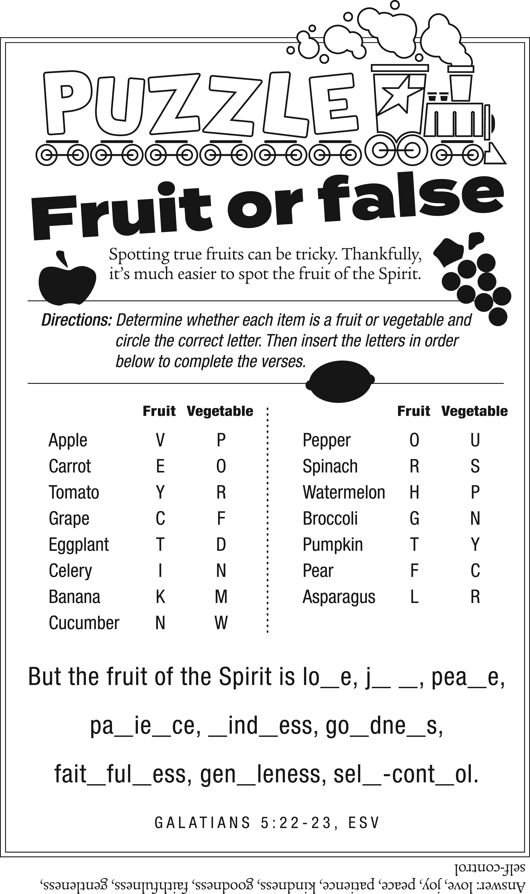
Services on Christmas Eve are at 8am and 10am
Christmas Eve Evening Service at 8pm
Christmas Day Service at 10am
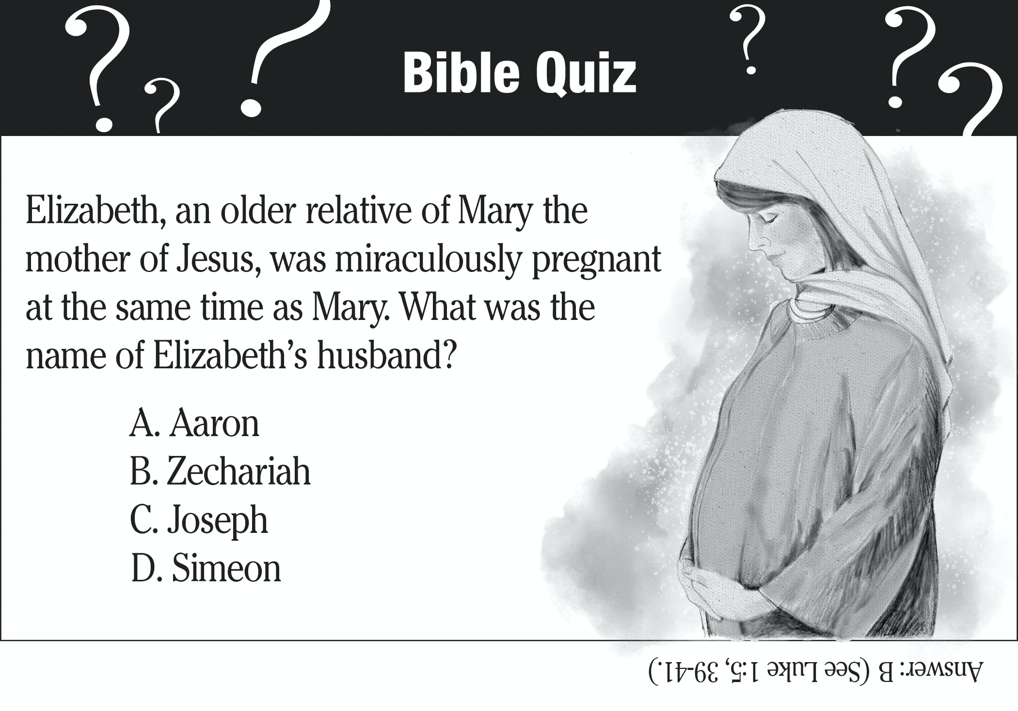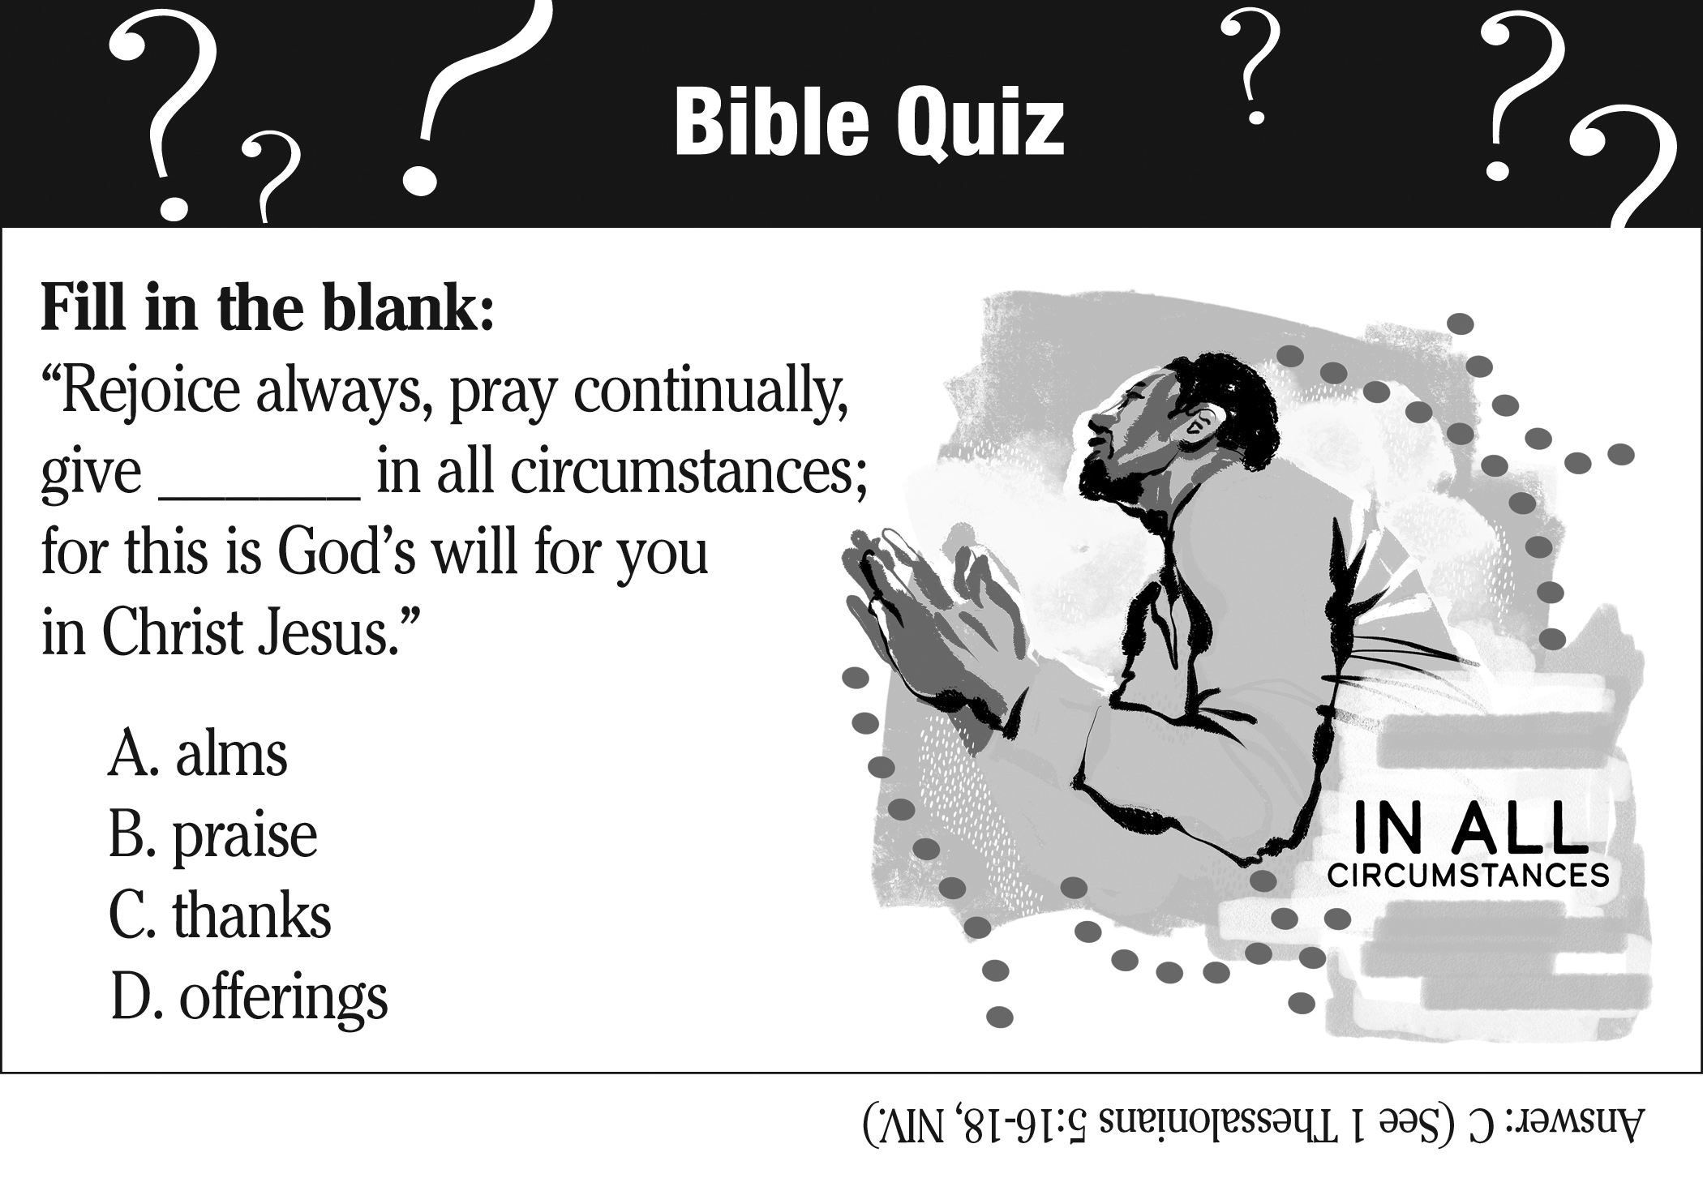

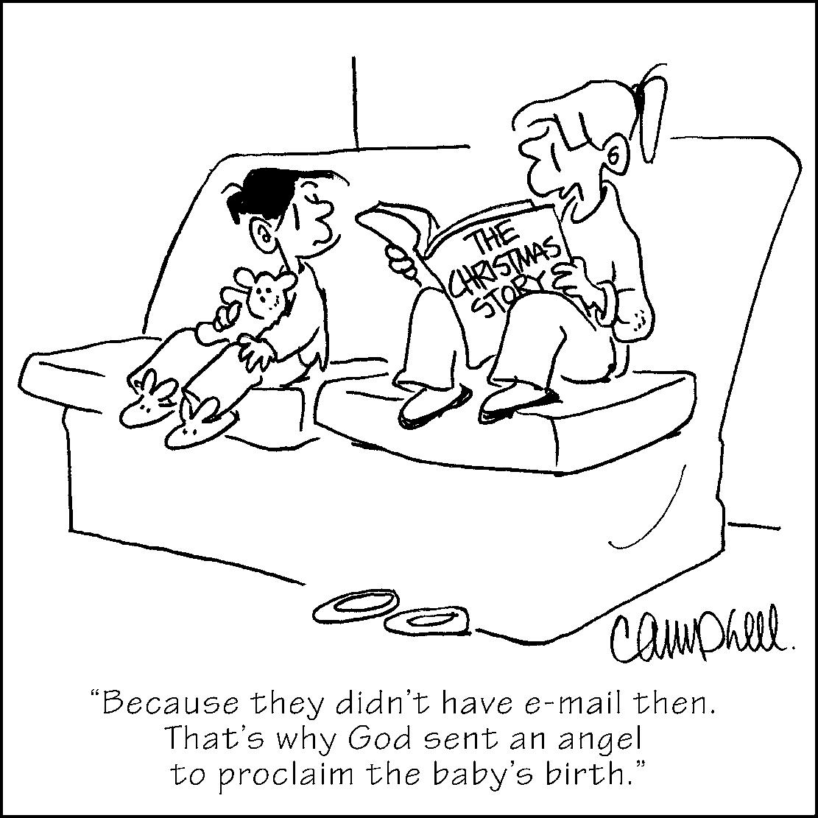
Dear St. Matthias,
Kent and I want to thank all of our helpers, known and unknown, that have supported us and prayed for us. The last few months have been very difficult in very many ways. Our St. Matthias family has been our support in all our ways through the twists and turns. Thank you very much! We love you! In God's Love, Kent and Doug

DECEMBER SERVICES, EVENTS, & SMALL GROUPS

SUNDAYS AT 8:00 A.M. Holy Eucharist (in-person only)

SUNDAYS AT 10:00 A.M. Holy Eucharist (in-person and streaming live at facebook.com/stmatthiaswhittier)

BIBLE STUDY/MORNING PRAYER: Wednesdays 10am, Chapel

MEN EATING BADLY: Saturday, December 2nd, 8:00 a.m. Greenleaf Café. Contact Tim Adams.

GREENING OF THE CHURCH: Saturday December 2nd , 2pm Sanctuary

OUR TIME: Tuesday, December 12th 2pm. Contact Mary Jean Christian.

VESTRY MEETING: Tuesday December 12th^{th}, 7:00 p.m. Chapel.

STITCHERY GROUP: Saturday, December 16th, 9:00 a.m. Chapel. Contact Ellen Mykkanen.

DAUGHTERS OF THE KING: Sunday, December 17th, 1p.m. Chapel

ST. ELIZABETH’S GUILD: Thursday, December 21^{st,} Noon, Contact Diana Jimenez.

BIBLIOPHILES GROUP: Thursday, December 19th , 6:30 p.m.. On Zoom, Contact Charles Carrillo.

ADVENT QUIET DAY: Saturday December 9th, 8:30-12, meet in Chapel

Thank you for sponsoring The Messenger.
If you’re interested in sponsoring
The Messenger by purchasing space on this page, please contact the church office.

Sunday Worship at St. Matthias: November 2023

December 3 Advent 1 Isaiah 64:1-9, 1 Corinthians 1:3-9, Mark 13: 24-37, Psalm. 80: 1-7,16-18
December 10 Advent 2 Isaiah 40:1-11, 2 Peter 3:8-15a, Mark 1:1-8, Psalm 85: 1-2, 8-13
December 17 Advent 3 Isaiah 61:1-4, 8-11, 1 Thessalonians 5:16-24, John 1:6-8,19-28,
Psalm 126
December 24. Advent 4 2 Samuel 7:1-11; 16, Romans 16:25-27; Luke 1:26-38; Canticle 15-Magnificat. (8am and 10 am)
December 25. Christmas Day Isaiah 9:2-7; Titus 2:11-14; Luke 2:1-14; Psalm 96
December 31. Lessons and Carols Genesis 3:8-15; Genesis 22:15-18;, Isaiah 9:2, 6-7, Isaiah 11:1-9, Luke 1:26-35, 38; Luke 2: 8-18; Luke 2:3-7; Matthew 2:1-12, John 1:1-14

We look forward to offering our worship services on more than one platform for streaming in the near future. We are awaiting new equipment that will allow us to do so. So please be patient and stay with us till that happens.

Non-Profit Org.
U.S. Postage
PAID
Permit #204
Whittier, CA

7056 Washington Avenue
Whittier, CA 90602
(562) 698-9741
RETURN SERVICE REQUESTED

DATED MATERIAL

DECEMBER 2023 20232023 2023 2023

