How to Watch Saint Matthias Services on Facebook without an Account

- Go to facebook.com/stmatthiaswhittier.
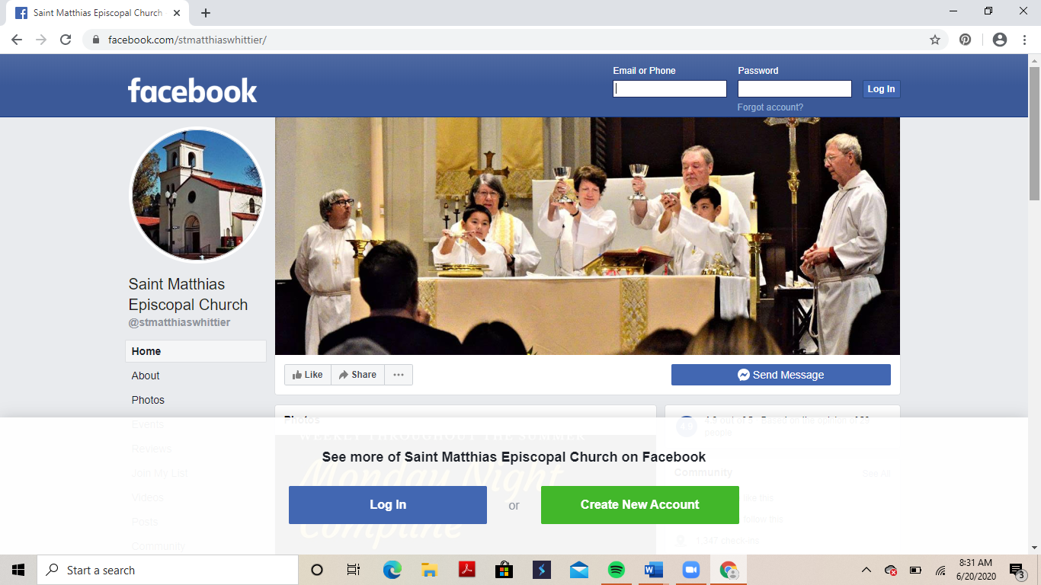

- Ignore the “Log In or Create New Account” prompt at the bottom of the page. Just keep scrolling down. It will disappear.

- Then it will reappear as a pop-up. Click “Not Now” at the bottom of the box.

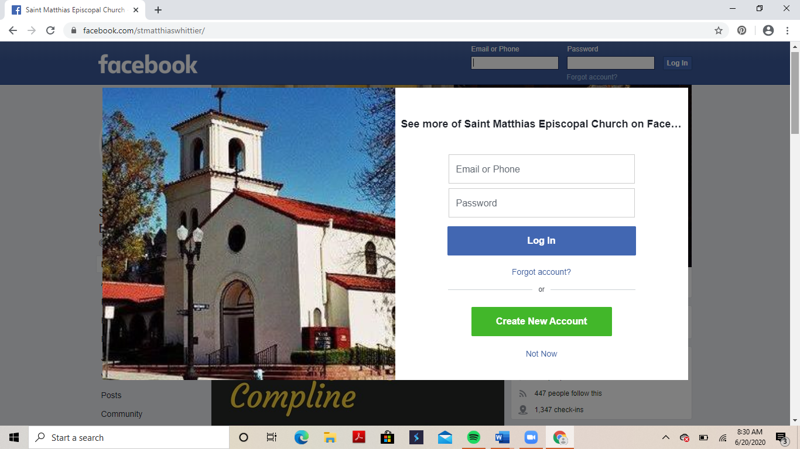
- The prompt returns to the bottom of the screen. Just ignore it.

- Scroll down until you see live video of the church service.

  - If you go to Facebook before the live video has started, you may need to refresh your page in order to see it. To refresh your page, click on the circular arrow button. This button may look different or be in a different place depending on the browser (e.g., Internet Explorer, Firefox, Safari, or Google Chrome) that you’re using. This example is from Google Chrome.

  - If you’re looking for the video after the service has ended, go to the section labeled “Videos.” You’ll see thumbnail images from the most recent services. Click the play button to watch the video, or scroll down and click “See All” underneath the thumbnails to see previous services.

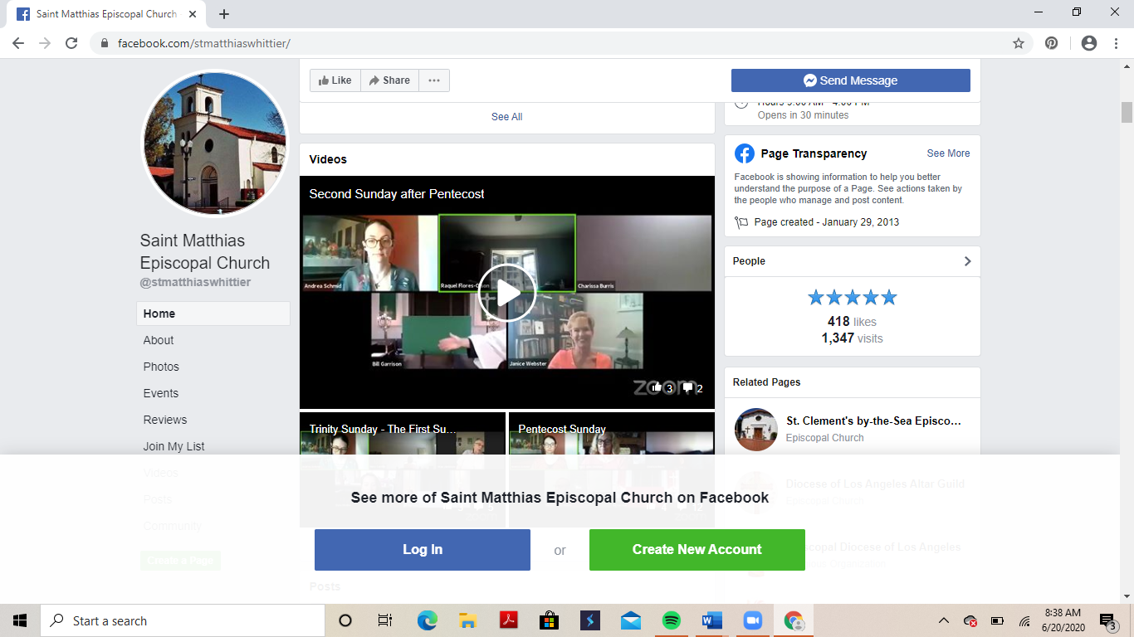
Refresh Page

- Click on the live video or thumbnail image to make it larger.

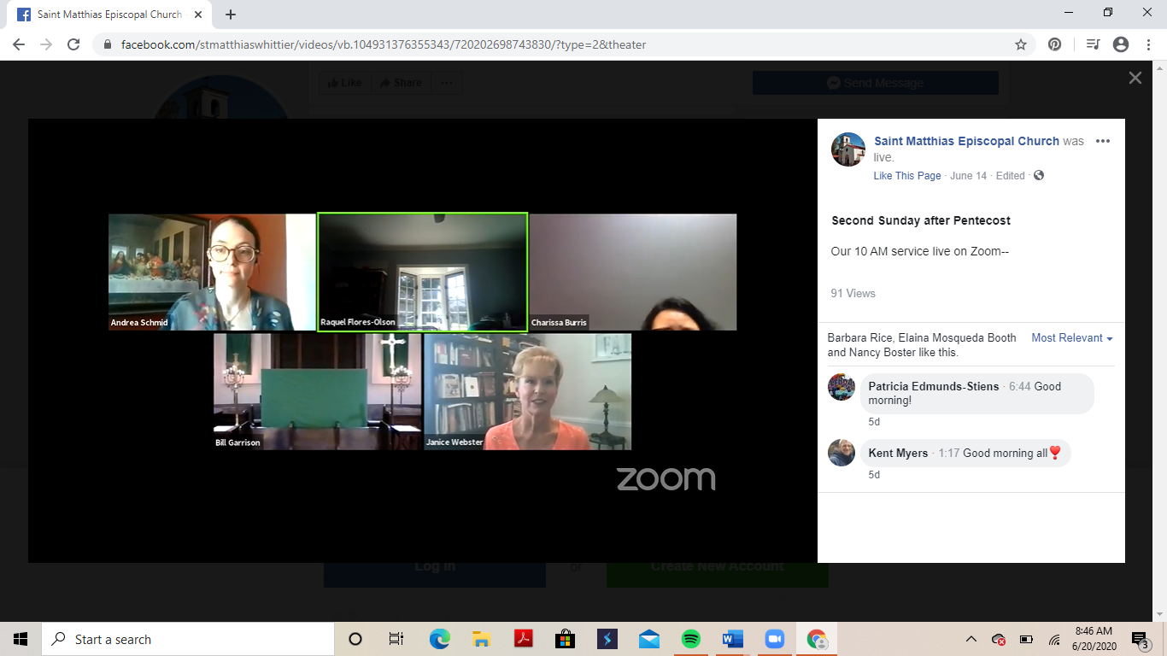

- To expand the video to full screen, hover your cursor (the arrow on your screen that you use to click things) over the bottom of the video. The video controls will appear. Click on the icon of two diagonal arrows pointing outward.
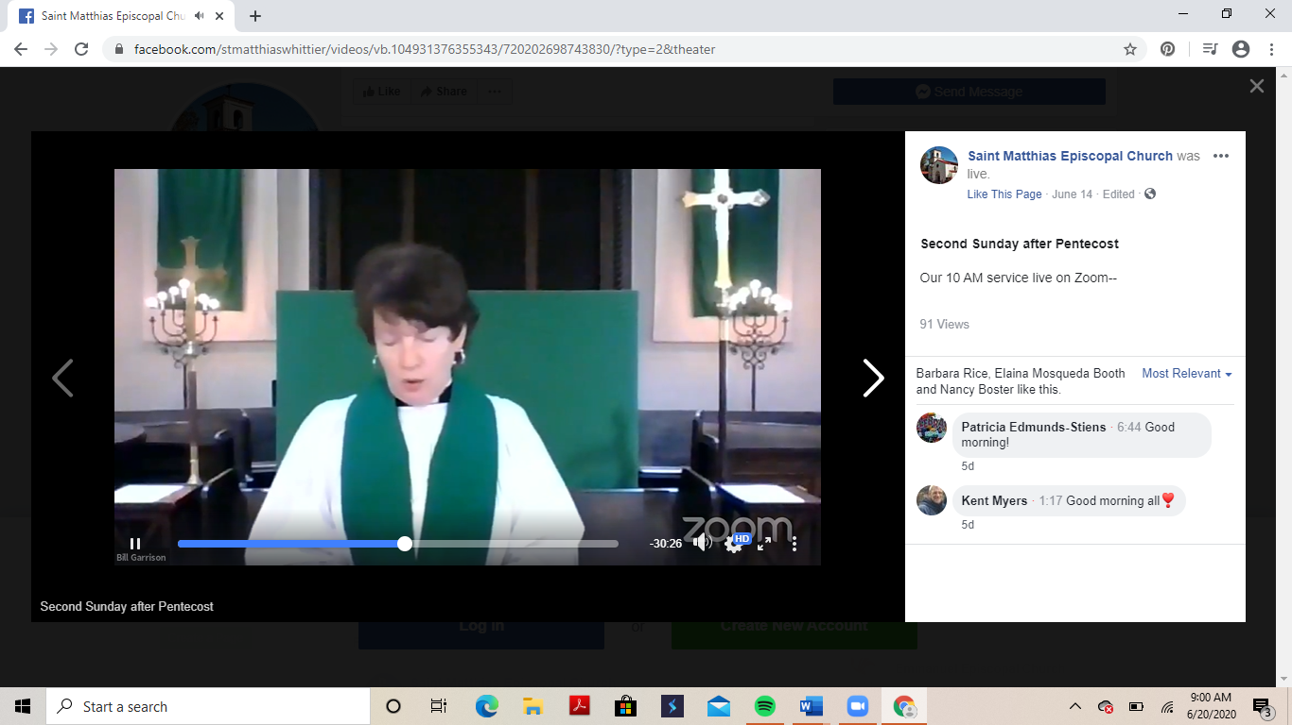

- Once you’re in full-screen mode, your controls will disappear. If you want to see the controls again, hover your cursor over the bottom part of the screen. To exit full-screen mode, press the escape (“esc”) key on your keyboard or click on the icon of two diagonal arrows pointing inward.
